Bandit Level 11
DG Interns Hub | Week 1 | OverTheWire Bandit Writeup

Objective
Decode a Base64-encoded password.

Activity summary
Suggested learning command / approach: base64 -d data.txt. Use only on the authorized OverTheWire training environment.

Key learning
Base64 decoding.

Evidence
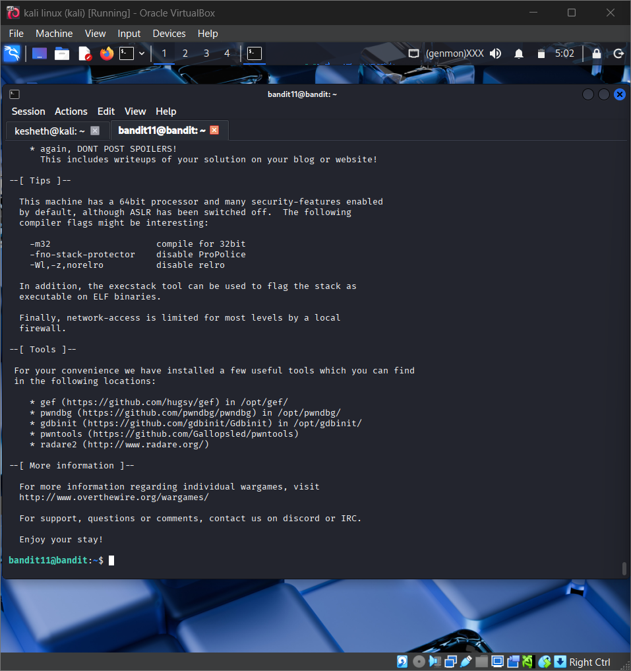
Screenshot: Bandit_Level_11.png
The screenshot is evidence of level activity/login; it may not show every solution step. No passwords are reproduced.

